[](https://www.facebook.com/ubssw)[](https://www.instagram.com/ubssw/)[](https://twitter.com/ubssw)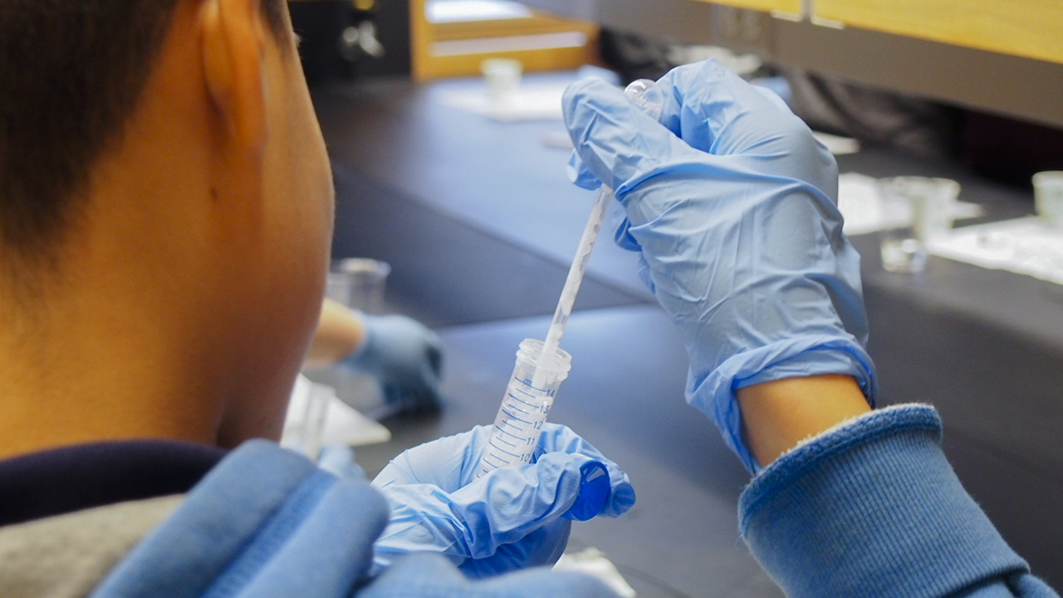

Photo Credit

JANE SMITH

**EVENT SPONSORS:** Event Sponsor One, Event Sponsor Two and Event Sponsor Three

UNiversity at Buffalo presents:

Place your event title here event title here

Lorem ipsum dolor sit amet, phasellus ornare an et convallis adipiscing mi, pretium vitae sit qui, sollicitudin nulla, lacus commodo semper sit. Congue in, mi sed faucibus porttitor, odio dui at, lobortis elit dui arcu tellus arcu sed. Acus et unus scelerisque nibh orci risus libero id, vivamus est sem odio ac in, risus libero id mollis fusce.

**DATE:** Jan. 00, 2018  
**TIME:** 2-5:30 p.m.   
**LOCATION:** Student Union, North Campus

For more information, visit **buffalo.edu**